GIT

# AULA 1

O que é GIT (cabeça dura, teimoso, pensa sempre que está certo, gíria inglesa)

Global information Tracker

CRIAR REPOSITÓRIO COM README

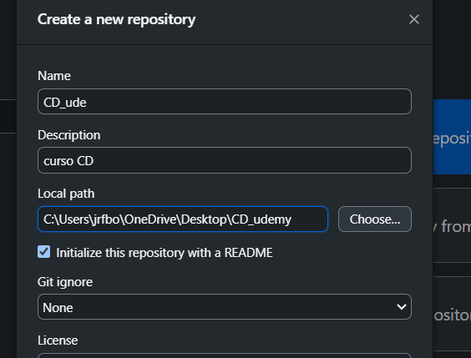

Mit license

$ git config --global user.name "Your Name Comes Here"  
$ git config --global user.email “[you@yourdomain.example.com”](mailto:you@yourdomain.example.com)

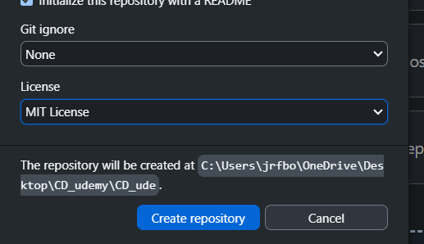

Git init = comando para iniciar um git

Git clone

MKDIR = cria uma pasta

CD = muda para aquela pasta

Mkdir checks (CRIA O REPOSITORIO CHECKS)

Cd checks (MUDA PARA A PASTA REPOSITORIO CHECKS)

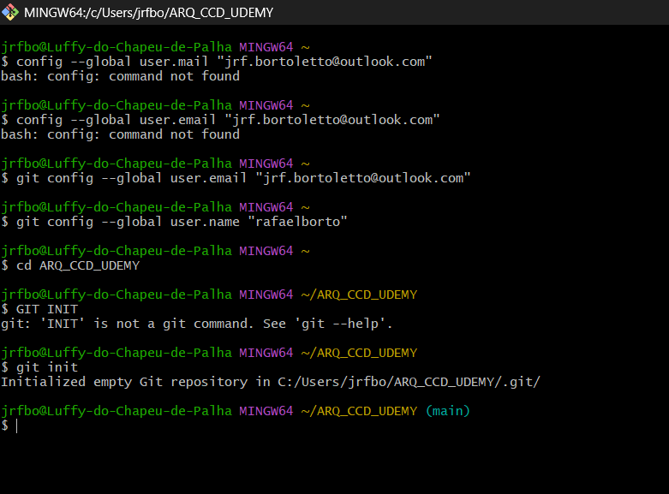LS –LA

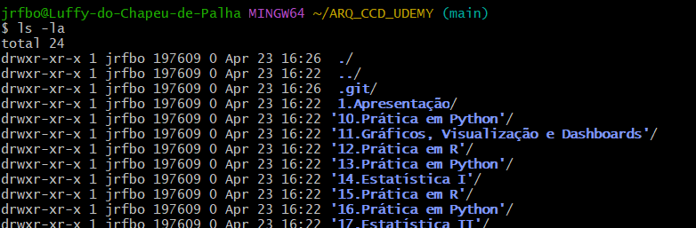

LS –L .GIT

git status

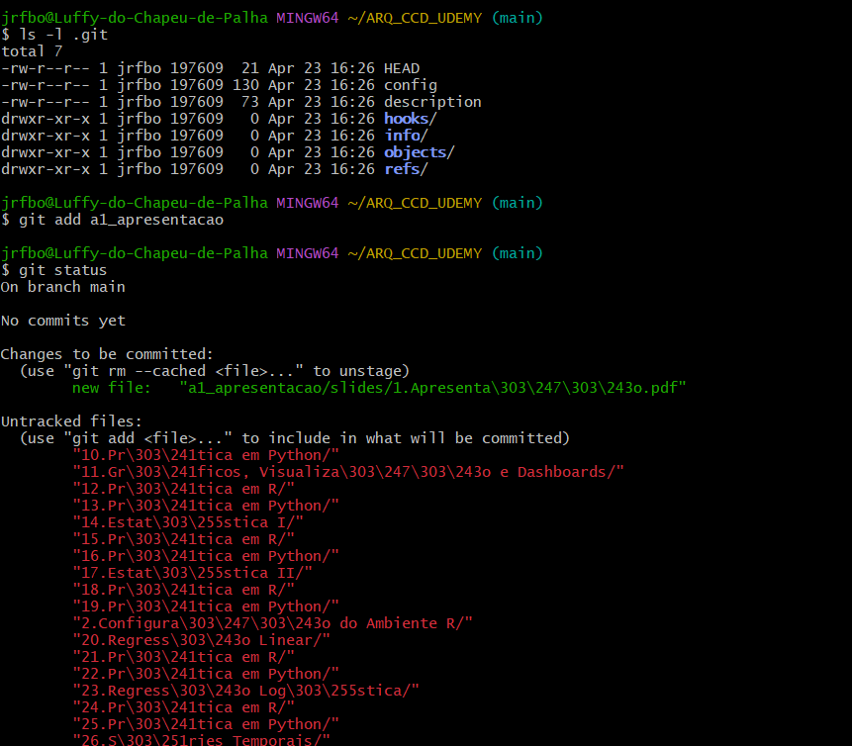

Adicionei ao repositório a primeira pasta a1_apresetancao

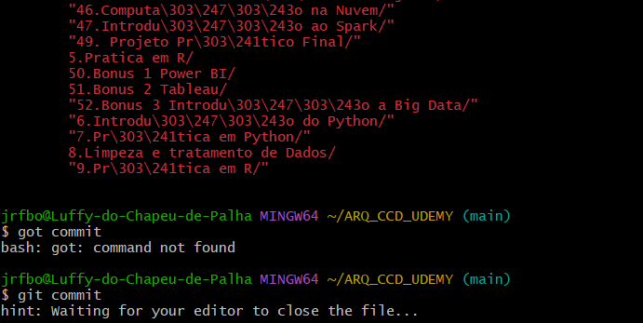

Abriu o Visual Studio

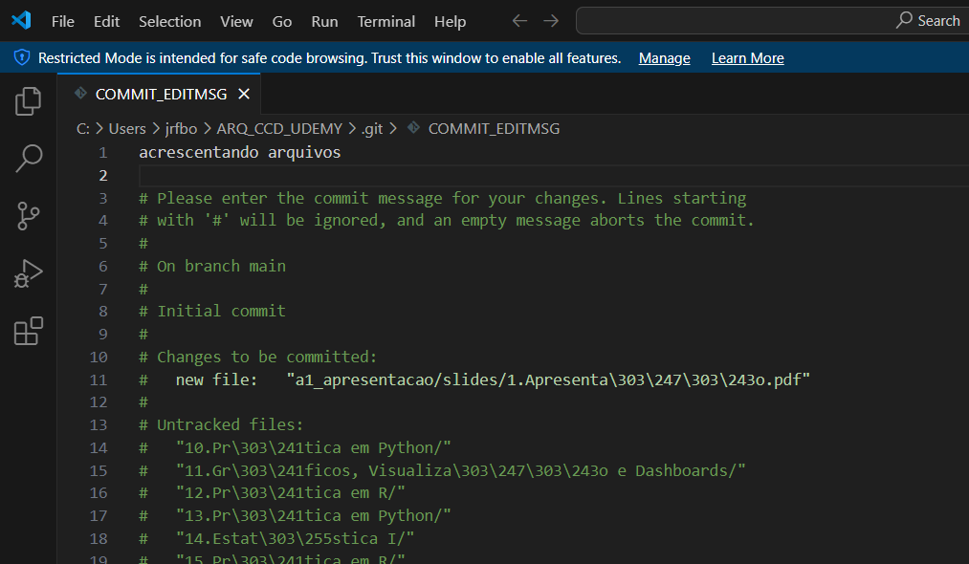

Mas há os UNTRACKED FILES, que não foram adicionados ao repositório

Só sair do editor,

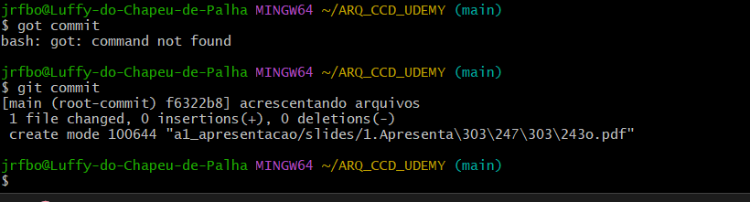

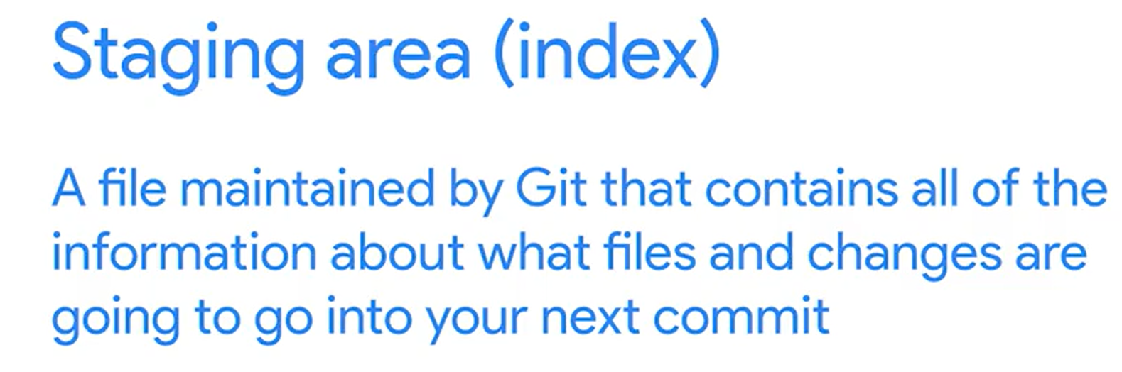

# AULA 2

In our last video, we mentioned that any Git project will consist of three sections. The Git directory, the working tree, and the staging area. The Git directory contains the history of all the files and changes. The working tree contains the current state of the project, including any changes that we've made. And the staging area contains the changes that have been marked to be included in the next commit.

This can still be confusing. So it might be helpful to think about Git as representing your project. Which is the code and associated files and a series of snapshots. Each time you make a commit, Git records a new snapshot of the state of your project at that moment. It's a picture of exactly how all these files looked at a certain moment in time. Combined, these snapshots make up the history of your project, and it's information that gets stored in the Git directory.

Now, let's dive into the details of how we track changes to our files. When we operate with Git, our files can be either tracked or untracked. Tracked files are part of the snapshots, while untracked files aren't a part of snapshots yet. This is the usual case for new files. Each track file can be in one of three main states, modified, staged or committed. Let's look at what each of these mean.

Play video starting at :1:19 and follow transcript1:19

If a file is in the modified state, it means that we've made changes to it that we haven't committed yet. The changes could be adding, modifying or deleting the contents of the file. Git notices anytime we modify our files. But won't store any changes until we add them to the staging area.

Play video starting at :1:37 and follow transcript1:37

So, the next step is to stage those changes.

Play video starting at :1:40 and follow transcript1:40

When we do this, our modified files become stage files. In other words, the changes to those files are ready to be committed to the project. All files that are staged will be part of the next snapshot we take. And finally, when a file gets committed, the changes made to it are safely stored in a snapshot in the Git directory.

Play video starting at :2:1 and follow transcript2:01

This means that typically a file tracked by Git, will first be modified when we change it in any way. Then it becomes staged when we mark those changes for tracking. And finally it will get committed when we store those changes in the VCS. Let's see this in action in our example Git repo. First, let's check the contents of the current working tree using ls-l. And then the current status of our files using t the Git status command. When we run Git status, Git tells us a bunch of things, including that we're on the master branch. We'll learn about branches later in the course. For now, notice how it says that there's nothing to commit and that the working tree is clean. Let's modify a file to change that.

Play video starting at :2:50 and follow transcript2:50

For example, we'll just add periods at the end of the message that our script presents to the user.

Play video starting at :3:25 and follow transcript3:25

So, now that we've made the change, let's call Git status again and see the new output. Again, Git tells us a lot of things, including giving us some tips for commands that we might want to use. These tips can come in real handy, especially when we're familiarizing ourselves with Git. See how the file we changed is now marked as modified? And that it's currently not staged for commit?

Play video starting at :3:51 and follow transcript3:51

Let's change that by running the Git add command, passing the disk usage py file as a parameter.

Play video starting at :4:4 and follow transcript4:04

When we call Git add, we're telling Git that we want to add the current changes in that file to the list of changes to be committed. This means that our file is currently part of the staging area, and it will be committed once we run the next Git command, Git commit. In this case, instead of opening up an editor, let's pass the commit message using the dash m flag, stating that we added periods at the end of the sentences.

Play video starting at :4:38 and follow transcript4:38

So, we've now committed our stage changes.

This creates a new snapshot in the Git directory.

Play video starting at :4:45 and follow transcript4:45

The command shows us some stats for the change made. Let's do one last status check.

Play video starting at :4:54 and follow transcript4:54

We see that once again, we have no changes to commit. Because the change we made has gone through the full cycle of modified, staged and committed. So to sum up, we work on modified files in our working tree. When they're ready, we staged these files by adding them to the staging area. Finally, we commit the changes sitting in our staging area, which takes a snapshot of those files and stores them in the database that lives in the Git directory. If the way Git works is not totally clear yet, don't worry. It will all sink in with a bit more practice.

Play video starting at :5:27 and follow transcript5:27

In our next video, we'll put this all together and go over the typical workflow when working with Git.

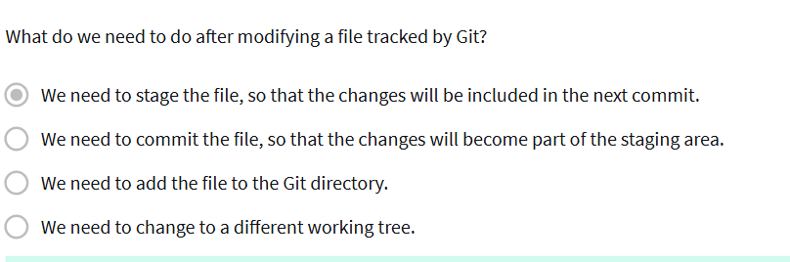

ENTREI DIRETAMENTE NO GIT BASH PELA PASTA

Usei o GIT STATUS

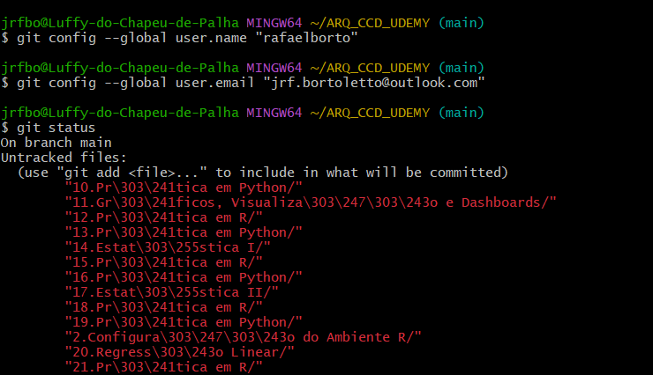

E O GIT LS –L

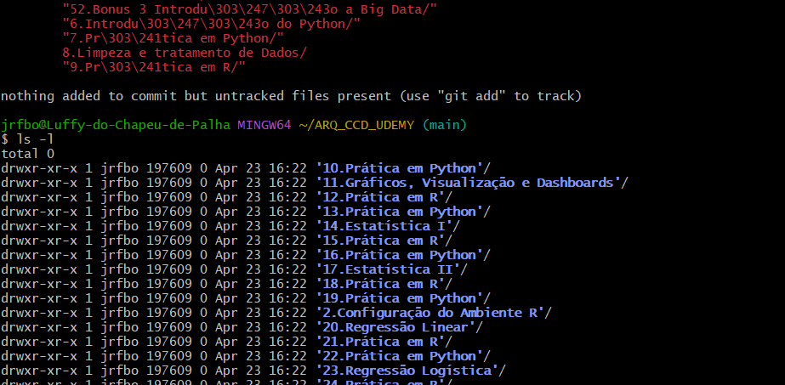

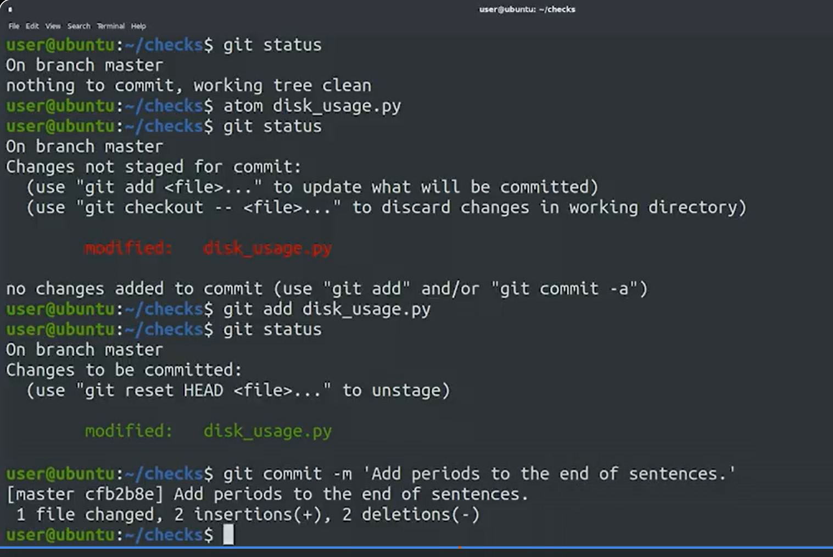

# AULA 3

mkdir scripts

cd scripts

git init

**Code output:**

Initialized empty Git repository in /home/user/scripts/.git/

git config -l

**Code output:**

[user.email=me@example.com](mailto:user.email=me@example.com)

user.name=My name

core.repositoryformatversion=0

core.filemode=true

core.bare=false

core.logallrefupdates=true

git status

git add all_checks.py

git commit

git commit -m 'Add a check_reboot function'

# AULA 4

In earlier videos, we discussed some of the basic concepts involved in working with Git. We saw that each repositor will have a Git directory, a working tree, and a staging area. And we called out that files can be in three different states, modified, staged, and committed. Let's review these concepts one more time by looking at the normal workflow when operating with Git on a day to day basis. First, all the files we want to manage with Git must be a part of a Git repository. We initialize a new repository by running the git init command in any file system directory. For example, let's use the mkdir command to create a directory called scripts, and then change into it and initialize an empty Git repository init. Our shiny new Git repository can now be used to track changes to files inside of it. But before jumping into that, let's check out our current configuration by using the git config -l command. There's a bunch of info in there, and we won't cover all of it. For now, pay special attention to the

user.email and the user.name lines, which we touched on briefly in na earlier video. This information will appear in public commit logs if you use a shared repository. For privacy reasons, you might want to use different identities when dealing with your private work and when submitting code to public repositories. We'll include more details about changing this information in our next reading. Okay, our repo is ready to work, but it's currently empty. Let's create a file in it, we'll start with a basic skeleton for a Python script, which will help us demonstrate

the Git workflow. As with any Python script, we'll start with the shebang line. For now, we'll add an empty main function, which we'll fill in later. And at the end, we'll just call this main function. All right, we've created our file. This is a script that we'll want to execute, so let's make it executable. And then let's check the status of our repo using git status command. As we called out before, when we create a new file in a repository, it starts off as untracked. We can make all kinds of changes to the file, but until we tell Git to track it, Git won't do anything with an untracked file. Do you remember what command we have to use to make Git track our file? That's right, we need to call the git

add command. This command will immediately move a

new file from untracked to stage status. And as we'll see later, it will also

change a file in the modified state to staged state. Remember that when a file

is staged, it means it's been added to the staging area and it's ready to be

committed to the Git repository. To initiate a commit of staged files,

we issue the git commit command. When we do this, Git will only commit

the changes that have been added to the staging area, untracked files or

modified files that weren't staged will be ignored. Calling git commit with no

parameters will launch a text editor, this will open whatever has been set as

your default editor. If the default editor is not the one

you'd like to use, there are a bunch of ways to change it. We'll include more

info about changing the default editor in the next reading. For now, let's

edit our message with Nano, which is the current default for this computer. We'll say that our change is creating

an empty all_checks.py file, then save and exit. Voila! We've just recorded a snapshot of the

code in our project, which is stored in the Git directory. Remember that every

time we commit changes, we take another snapshot, which is annotated with a

commit message that we can review later. Okay, that's how we add new files, but

usually we'll modify existing ones. So let's add a bit more content to our

script to see that in action. We'll add a function called

check_reboot, that will check if the computer is pending a reboot. To do that, we'll check if the

run/reboot-required file exists. This is a file that's created on our

computer when some software requires a reboot. And of course, since we're

using os.path.exists, we need to add import os to our script. All right, we've added a function to

our file. Let's check the current status using

git status again. Our file's modified, but not staged. To stage our changes, we need to call

git add once again. Okay, our changes are now staged. What do we need to do next? You got it,

we have to call git commit to store those changes to the Git directory. This time, we'll use the other way of

setting the commit message. We'll call git commit -m, and then pass

the commit message that we want to use. So in this case, we'll say that we've

added the check_reboot function. With that, we've demonstrated the basic

Git workflow. We make changes to our files, stage

them with git add, and commit them with git commit. Are you starting to feel

more comfortable with this process, and see how it fits within the rest of your

tasks? If there's anything that's not totally

clear yet, remember, that the only way to get familiar with these concepts is

practice. Feel free to try these examples out on

your computer as we go along, until you get comfortable with these commands. Up next we'll talk more about how to

write useful commit messages.